**Measurement Systems**

**LAB 5: ECG amplifier design**

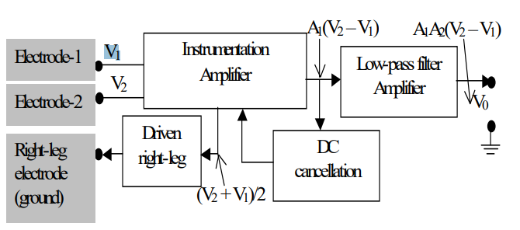

A general block diagram of a modern ECG amplifier is shown in figure.

It is designed around an instrumentation amplifier. In addition to the instrumentation amplifier it contains:

• An automatic offset (DC) cancellation circuit to keep the output always zero averaged

• A driven-right leg circuit to provide electrical safety and reduce the interference under normal operational conditions, and

• A low-pass filter that provides further amplification and limit the bandwidth of the overall system.